Future improvements for our project.
Moving forward with our project, we will be hoping to improve our overall design. We will purchase a small bin and cut out the necessary holes for the components to be mounted on. We will then complete the design and start working on a way that we can collect data through the internet using our device. So far, we only have the ultrasonic sensor working with the Arduino board however we are confident that we can design a fully constructed Arduino smart bin.

Components that we will introduce in future design:
Servo motor: The servo motor will be used to open the lid of the bin and close it. A piece of wire or thread will be tied around the motor which will then attach to a piece of cardboard/plastic attached to the roof of the lift allowing the lid to open and close from the rotation of the motor.
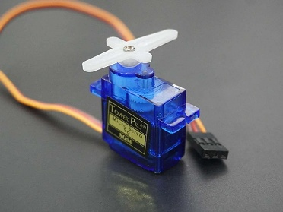
LED: The LED will be used on the front of the bin and will indicate that the bin is open. The LED will flash red when the device detects that the bin is open and will remain on until the bin closes.
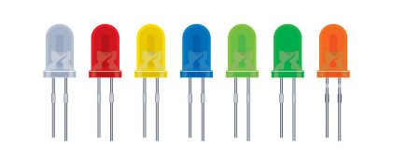
LED Display: The LED Display will be used to show a message to the user before and after they have inserted their waste.
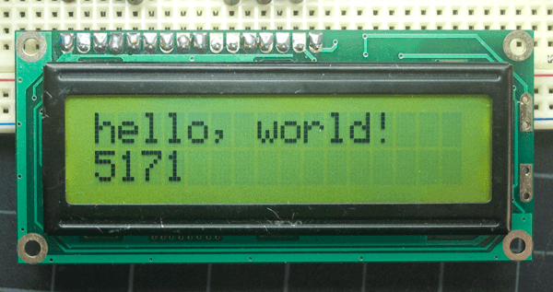
Connecting to the internet and collecting data:
We will use PushingBox online to connect our Arduino device to the internet that will allow the user to record data and send it to an online Google Spreadsheet. We are hoping to be able to track how many times the bin is used (open and closed). We will take this as an average number and figure out how many uses would be needed to fill the bin. We will then return an email or message to the user to tell them when the bin is full and needs to be emptied.

